Invites you to the 13th annual
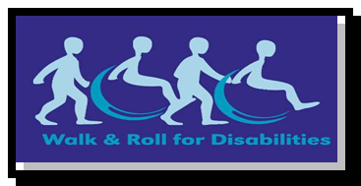

Sunday, March 5, 2017 10:30 am

Oak View Mall, 2nd floor, by the Food Court

Last year over 300 people came out to Walk and Roll to lend their support.

For over fifteen years, the Meyer Foundation for Disabilities (MFD) has funded the Munroe Meyer Institute’s Recreation Therapy Adult Respite and Habilitation Programs. This center-based program serves participants over the age 21. The program provides weekly recreational activities and social interaction opportunities with high ratios of staff and volunteer support. Activities include cooking, swimming, art projects, social dance, karaoke, holiday theme parties and community outings
MFD has also funded additional opportunities at Rec Therapy to expand their current cooking classes and community outing programs to allow more adults the opportunity to engage in recreational and leisure programs.
MFD also partners with community organizations such as Ollie Webb Center, Inc. to sponsor the only Next Chapter Book Club in Nebraska; HETRA – carriage driving and helmets; Nebraska Outdoor Lutheran Ministries (NLOM) for the Jay Novicki Program; Why Arts? - to sponsor dance lessons; and the Omaha Public Library Foundation to purchase High Interest-Low Vocabulary books.
For more information please visits these websites
Meyer Foundation for Disabilities Website: www.mfdisabilities.org
UNMC Munroe-Meyer Recreational Therapy Dept.: www.unmc.edu/mmi/departments/rt/index.html

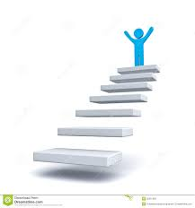
Ways you can Step Up for Walk & Roll for Disabilities 2017
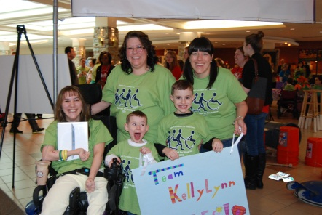
Step 1: Register to Walk and Create a Team You, your family and friends can register as individuals or as a team. You can register on line at www.mfdisabilities.org after December 1, 2016. Prizes will be given for teams that have over 20 individuals and the team with the largest number of members.
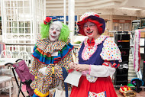
Step 2: Team Contributions
Teams that raise over $500 in contributions will be entered to win an Apple iPad.

Step 3: Corporate Sponsorship Contact local business to be a corporate sponsor. You can obtain information about corporate sponsorship at info@mfdisabilities.org
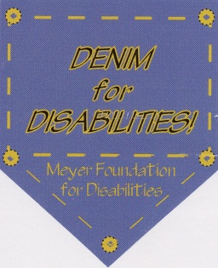
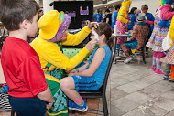
Step 4: Eat at Don & Millie’s
On the 2nd Wednesday of each month from 4:30 – 9:00 pm, the Don & Millie’s Restaurant at 4430 Farnam will donate 20% of the bill to MFD

Step 5: Denim for Disabilities Organize a day at your business or place of work to support the Meyer Foundation for Disabilities. Individuals who make a donation will be able to wear jeans to show their support. MFD will provide stickers for project coordinators.
You can obtain information about Denim for Disabilities at info@mfdisabilities.org. calcall 402-559-5771 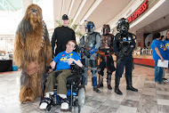
Step 6: Prize Drawings
Donate a prize or ask a business for a prize. If you have any questions please contact MFD at (402) 559-5771 or email info@mfdisabilities.org.

